Apple iPhone 13

Type of device: Mobile
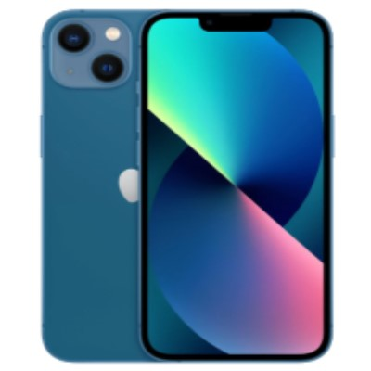

Actual Display Size : 6.1 inches
Button Type : Touchscreen
Operating System : Apple IOS
Version Number : iOS 15
Network Capability : 3G,4G,5G
Year of Release : 2021
Average Price : $1608 as of 28 09 2021

Accessibility Features:

Cognitive
- Additional Instructions
- Copy and Paste
- GPS
- Photo Telephone List
- Screen Timeout Disabled
- Simple Instructions
- Simple Reminders
- Simplify Display
Voice Notes

Hearing Impairment and Deaf
- Allows for sign language communication
- Bluetooth or Wi-Fi
- Closed Captioning
- Front Facing Camera
- Hearing Aid Microphone Coupling
- Hearing Aid Telecoil Coupling
- Text Messaging/SMS
- Vibrating Alerts - Adjustable
- Video Communications - Two-way
Visual Alerts - Incoming Calls

Vision
- Battery Alert - Audible
- Bluetooth or Wi-Fi
- Braille Display Support
- Brightness Adjustable
- Dictation / Speech-to-Text
- High Contrast Mode
- Personalised Shortcuts
- Power Cue
- Screen Magnifier
- Screen Reader
- Text Size Adjustable
- Text Style Adjustable
- Voice Control /Personal Assistant
Voiced Menus

Speech
- Allows for sign language communication
- Bluetooth or Wi-Fi
- Messaging Options - Email
- Messaging Options - IM
- Messaging Options - MMS
- Predictive Text
SMS Personalisation and Reuse

Physical
- Automatic Answer
- Bluetooth or Wi-Fi
- Dictation / Speech-to-Text
- Gesture Based Navigation
- Predictive Text
- Speaker-phone option
- Stylus or Prosthetic Device support
- Switch control option
- Voice Control / Personal Assistant
- Voice Recognition for Accessing Features
Voice Recognition for Dialling

How and where to get it from?
You can buy this phone from Harvey Norman, Officeworks, Apple, and other retailers.

More information is available on:
Apple iPhone 13 Web Page
Apple iPhone 13 Specifications Web Page
Apple iPhone 13 User Guide
Apple Accessibility Website

